Topic:  The Periodic Table | Learning Target: 1.4  Date: February 4th
Essential Question: What information can be found in a “square” on the periodic table?

Student Questions: | Notes:  Atomic Number = the number of protons an atom contains.  Atomic Mass = the average mass of all known isotopes for a given element.  Chemical Symbol = the abbreviation for a chemical name.  Chemical Name = the name of the element.  Group = a vertical column on the periodic table.  Period = a horizontal row on the periodic table.  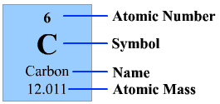
Summary: In one square of the periodic table on finds the following information: chemical name, chemical symbol, atomic number (protons), and atomic mass (protons + neutrons).

