Unit 5: Chemical Reactions – Webquest
https://tinyurl.com/3zvjdqg
- What is a chemical reaction?

http://tinyurl.com/bcm37
- What are the ten signs that a chemical reaction has occurred?

http://tinyurl.com/gq2p7ed
- What nine factors can influence the rate of a chemical reaction?

http://tinyurl.com/zfrsr3h
- Describe each of the five types of chemical reactions below.

  - Synthesis (addition or combination) Reactions

    - Definition

    - Example

    - General (Generic) Formula/Equation

  - Decomposition (dissolution) Reactions

    - Definition

    - Example

    - General (Generic) Formula/Equation
  - Single Replacement (displacement) Reactions

    - Definition

    - Example

    - General (Generic) Formula/Equation

  - Double Replacement (displacement) Reactions

    - Definition

    - Example

    - General (Generic) Formula/Equation

  - Combustion Reactions

    - Definition

    - Example

    - General (Generic) Formula/Equation

- Visit: https://tinyurl.com/jm7rhcj (Note: scroll down to “Reaction Type 6: Acid-Base”)

  - Acid-Base (Neutralization) Reactions

    - Definition

    - Example

    - Generic Example

The following chart is a flow chart that helps one determine the type of reaction based on a chemical equation.
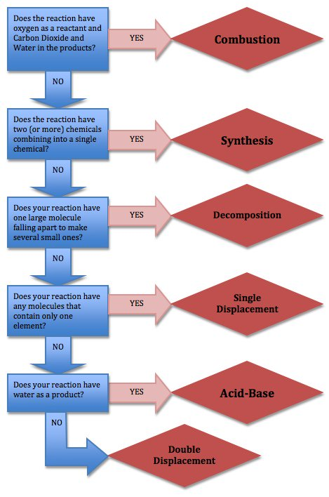

Continued
- Visit any one of the following websites to practice balancing chemical equations. When you successfully balance a reaction record the results below, include the type of reaction.
Option 1 – http://tinyurl.com/c2ogkmg
Option 2 – http://tinyurl.com/ktuuhrb Note: for option 2 & 3 you must “click to enable flash player”
Option 3 - http://tinyurl.com/jxvl2em
Type of Reaction | Balanced Chemical Equation

What does the Law of Conservation of Mass say about a chemical reaction?

Continued
Balance each equation below and indicate the type of reaction.

1. ____N₂ + ____H₂ ____ NH₃ Type of Reaction ________________
2. ____Al₂O₃ + ____Fe ____ Fe₃O₄ + ____ Al Type of Reaction ______
3. ____KClO₃ ____ KCl + ____ O₂ Type of Reaction ________________
4. ____K + ____MgBr₂ ____KBr + ____Mg Type of Reaction ______
5. ____P + ____O₂ ____P₂O₅ Type of Reaction ________________
6. ____Ag₂O ____Ag + ____O₂ Type of Reaction ________________
7. ____Al + ____ H₂SO₄ ____Al₂(SO₄)₃ + ____ H₂ Type of Reaction ____
8. ____ Be₂C + ____H₂O ____Be(OH)₂ + ____CH₄ Type of Reaction ____
9. ____NaClO₃ _____ NaCl + ____O₂ Type of Reaction _________
10. ____NH₃ + ____ CuO ____Cu + ____ N₂ + ____ H₂O Type of Reaction ____
11. ____Al + HgCl₂ ____AlCl₃ + ____Hg Type of Reaction ____
12. ____Cu + ____AgNO₃ ____Cu(NO₃)₂ + ____Ag Type of Reaction _______

