Chemical Reactions vs. Nuclear Reactions
Instructions: complete the following data table by visiting each of the stations around the room. You will start at one station with a group of students. Every three minutes you will be prompted to switch stations.
 | Chemical Reactions | Nuclear Reactions
Definition

Characteristics

Types of…

Equations (generic)

Examples of / uses for….

Reversibility…

Conservation of Mass or Energy

Energy involved….

Conclusion: form a group of your choice and make a Venn Diagram depicting the similarities and differences between chemical reactions and nuclear reactions.
Definition…
Chemical Reactions – A chemical reaction is a process that leads to the transformation of one set of chemical substances to another. Chemical reactions involve changes in electrons during the making/breaking of chemical bonds, the atom’s identity does not change (no change to the nucleus). Chemical reactions are described with a chemical equation.
Nuclear Reactions – A nuclear reaction is a process that involves a change in the identity or characteristics of an atomic nucleus. Alternatively, a nuclear reaction is a process in which the structure and energy content of an atomic nucleus are changed via interactions with other nuclei or particles.

Characteristics of….
Chemical Reactions – all chemical reactions involve forming a new substance. The reactants (the atoms/molecules you start with) have their chemical bonds broken and rearranged to form products (the atoms/molecules you end with). Remember the atoms themselves don’t change however the chemical bonds between the atoms can/do change.
Nuclear Reactions – all nuclear reactions involve a change to the nucleus of an atom. Usually the atom changes into a new element accompanied by a release of energy. The atoms/particles you start with (reactants) can be completely different from the atoms/particles you end with (products). Remember that during nuclear reactions (unlike chemical reactions) the atoms/particles themselves change into different atoms/particles.

Types of…….
Chemical Reactions –
- Synthesis Reaction, two or more substances combine to form a more complex product(s).
- Decomposition Reaction, a single substance is broken apart to form smaller/less complex product(s).
- Single Replacement Reaction, one element in a compound is replaced by a different element.
- Double Replacement Reaction, two elements in two different compounds switch places.
- Combustion Reaction, a carbon-containing molecule combines with oxygen to form carbon dioxide, water, and energy.
- Acid-Base Reaction, a specific type of double displacement reaction occurring between an acid and a base, producing a salt and water.

Nuclear Reactions –
- Fission, a large nucleus is split apart into smaller nuclei/particles.
- Fusion, two smaller nuclei combine to form one larger nucleus.
- Alpha Decay, a particle consisting of 2-neutrons & 2-protons (alpha particle) is ejected from a nucleus.
- Beta Decay, a high-energy electron (beta particle) is emitted from the nucleus of an atom.
- Gamma Decay, a high-energy electromagnetic wave (gamma ray) is emitted from a nucleus.

Equation (General)…
Chemical Reactions –
- Synthesis: A + B AB
- Decomposition: AB A + B
- Single-Replacement: AB + C AC + B
- Double-Replacement: AB + CD AC + BD
- Combustion: Carbon + Oxygen Carbon Dioxide + Water + Energy
- Acid/Base: HA + BOH Water + BA
Nuclear Reactions –
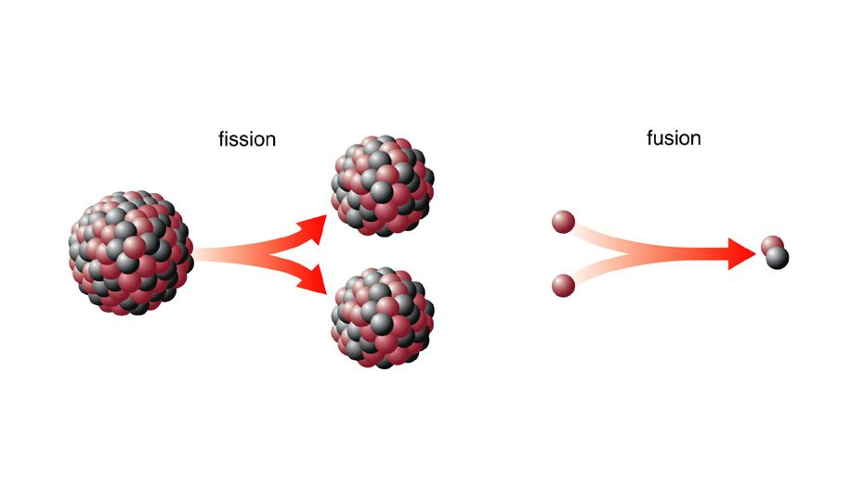
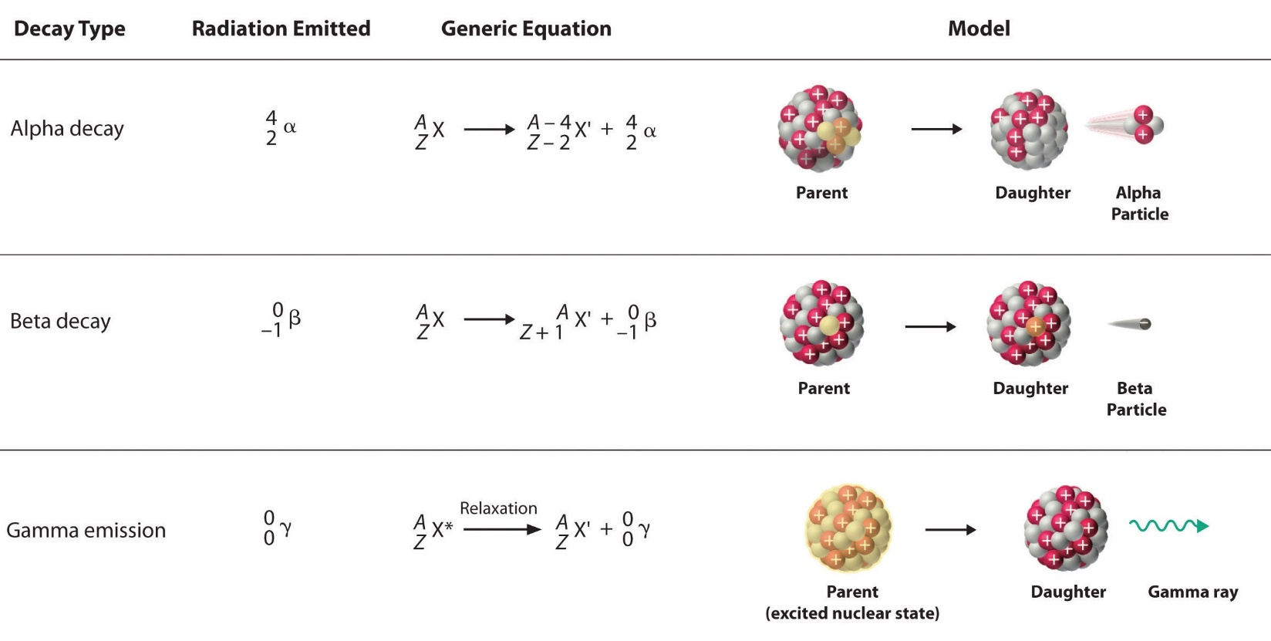
Examples of & Uses for…..
Chemical Reactions –
- Photosynthesis – plants convert carbon dioxide and water into sugar and oxygen. This is one of the most common, and important, chemical reactions.
- Cellular Respiration – this is the opposite of photosynthesis and is performed by all animals. Animals combine carbon-containing molecules with oxygen to produce carbon dioxide and a lot of energy.
- Digestion (metabolism) – thousands of chemical reactions take place during digestion allowing animals to use energy from sugars, fats, and proteins obtained in the diet.
- Cooking – heating food causes chemical changes in the food that make nutrients easier to obtain.
Nuclear Reactions –
- Radioisotopes – these radioactive isotopes allow chemists/physicist to track the location of the particle.
- Food irradiation – exposing food to a small amount of gamma radiation destroys bacteria and provides a longer expiration date for the food.
- Inspection – radioactive material can be used to inspect the quality of welds or to accurately measure thickness of sheet metal (like aluminum foil).
- Radio Dating – radioactive material can be used to estimate how old something is.
- Sterilization – hospitals use gamma radiation to sterilize medical products and supplies.
- Generate electricity – nuclear fission is commonly used to generate electricity.

Reversibility…..
Chemical Reactions – theoretically all chemical reactions are reversible however, in practice we find that some reactions are reversible while others are irreversible (practically speaking).
- Irreversible reactions – are those in which the reactants convert to products and once the products form they cannot be convert back into the reactants.
- Reversible reactions – are those in which the reactants can convert to products and vice-versa (products convert to reactants)
Nuclear Reactions – theoretically all nuclear reactions are reversible however, in practice we cannot reverse these reactions and we do not see nature reversing these reactions. So effectively nuclear reactions are not reversible.

Conservation of Mass/Energy….
Chemical Reactions – The Law of Conservation of Mass applies directly to chemical reactions. It states that during a chemical reaction mass is neither created nor destroyed, only changed. This means that if you get the mass of reactants (starting material in a chemical reaction) before the reaction happens and you collect all of the products (ending material in a chemical reaction) you will have the same mass you started with. In other words: the mass of the products is exactly equal to the mass of the reactants.
Nuclear Reactions – The Law of Conservation of Mass does not apply to nuclear reactions because, in nuclear reactions, some mass is converted to energy. However, The Law of Conservation of Energy does apply to nuclear reactions. The total energy before and after a nuclear reaction will be identical. You may get new particles but the energy will remain constant throughout the process of a nuclear reaction.

Energy involved….
Chemical Reactions – There will be a difference in energy between the reactants and products in a chemical reaction. Energy can be released or consumed during a chemical reaction. Note that chemical reactions can release energy up to about 10³ kJ which is significantly less than the amount of energy nuclear reactions can release 10⁸ kJ
- Exothermic Reactions – are reactions that produce energy as a product.
- Endothermic Reactions – are reactions that consume energy as a reactant.
Nuclear Reactions – while it is possible for nuclear reactions to consume and produce energy for our purposes we will define nuclear reactions as being exothermic (producing energy as a product).
- Nuclear Fission – produces (net) energy.
- Nuclear Fusion – produces (net) energy.
- Nuclear Decay – produces (net) energy.
  - Note: the amount of energy released by nuclear reactions (10⁸kJ) is 5 orders of magnitude (that is a lot) larger compared to chemical reactions (10³kJ).

