Wave Characteristics: frequency, amplitude, speed, & wavelength
Harmonic # | Frequency (Hz) | Wavelength (m) | Speed (m/sec) Note: speed is frequency × wavelength) | Amplitude (cm)
1
2
3
4
5
6
7
8
9
10
Construct the following two graphs:
- Plot Frequency on the x-axis and Wavelength on the y-axis.
- Plot Frequency on the x-axis and Amplitude on the y-axis.
Answer the following questions using your data table and your graphs.
- Describe how the frequencies of the different harmonic patterns are related to each other.
- How does the speed of the wave changes compare to the changes in frequency and separately wavelength?
- If the frequency increases what happens to the wavelength? If the frequency decreases what happens to the wavelength? What type of mathematical relationship is this?
- If the frequency increases what happens to the amplitude? If the frequency decreases what happens to the amplitude? What type of mathematical relationship is this?
Use the wave-images to answer the following questions:
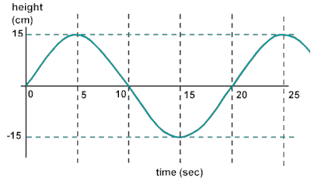
- Is this a transverse or a longitudinal wave?
- What is its wavelength? (use a ruler to measure the wavelength, on the image, in centimeters)
- What is the frequency of this wave?
- How fast is this wave traveling?
- What is the amplitude of this wave?

