Nuclear Reactions & Radioactivity
Instructions: create a poster using the information found in your “Group” below.
Group 1 – Nuclear Fission
- Definition: fission is the splitting of large atoms into smaller atoms and particles.
- Natural Occurrence: fission reactions rarely occur in nature.
- Byproducts: fission produces many highly radioactive particles
- Required conditions: critical mass of the substance and high-speed neutrons.
- Energy Requirement: fission requires a small amount of input energy.
- Energy Released: fission is used in nuclear power plants and produces a large amount of energy.
  - Example: one kilogram of uranium contains 2 million times the energy in one kilogram of coal.
- Fuel: uranium is the primary fuel used in power plants (nuclear fission)
- Example Equation: ²³⁵₉₂U + ¹₀n → ⁹⁰₃₈Sr + ¹⁴³₅₄Xe + 3¹₀n
- Image:
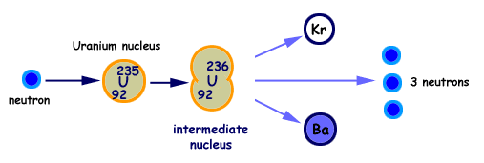
Group 2 – Nuclear Fusion
- Definition: fusion is the process of combining two smaller atoms into a larger atom.
- Natural occurrence: fusion occurs in stars.
- Byproducts: fusion produces an extremely small number of radioactive particles (mostly from the fission trigger)
- Conditions: high density and extremely high temperatures are necessary for fusion to proceed.
- Energy Requirement: very high energy is needed to overcome the electromagnetic repulsive force.
- Energy Released: the energy released by fusion is 3 times that of fission so 1 kg of fused atoms would produce 6 million times more energy compared to 1 kg of coal.
- Fuel: Hydrogen isotopes, deuterium and tritium, are the primary fuel in earth-based fusion reactions.
- Example Equation: ²₁H + ²₁H ⁴₂He + Energy
- Image:
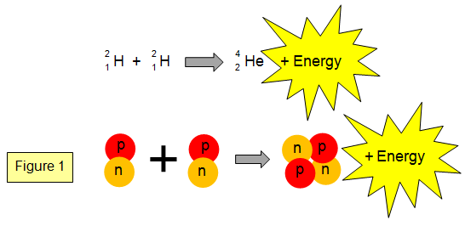
Group 3 – Alpha Decay/Radiation
- Definition: alpha decay is the release of 2-protons and 2-neutrons (an alpha particle) from the nucleus of a large, unstable atom.
- Particle: the alpha particle consists of 2-protons and 2-neutrons with an overall 2+ charge. This is a helium nucleus (helium is an alternative name for an alpha particle.)
  - Particle Symbol: ⁴₂He²⁺ or
- Changes to Nucleus: The mass number is reduced by 4. The atomic number is reduced by 2. This means that an atom undergoing alpha decay literally turns into a different atom (transmutation)
- Example Equation: ²³³₉₂U ²²⁹₉₀Th + ⁴₂He²⁺
- Image:
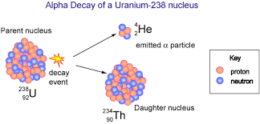

Group 4 – Beta Decay/Radiation
- Definition: beta decay is the release of a high energy electron from the nucleus of an unstable nucleus. A neutron in the nucleus splits into a proton and an electron. The proton stays in the nucleus, the electron is emitted as a beta particle.
- Particle: a beta particle is a high-energy electron.
  - Particle Symbol: ⁰₋₁e or ⁰₋₁β
- Changes to Nucleus: when beta decay occurs the mass number of the atom stays the same however, the atomic number increases by one. (this means the atom is turned into a different atom, known as transmutation)
- Example Equation: ²³⁴₉₀Th ²³⁴₉₁Pa + ⁰₋₁e
- Image:
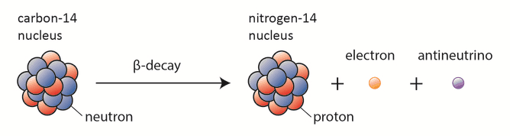

Group 5 – Gamma Decay/Radiation
- Definition: a large unstable nucleus emits energy in the form of electromagnetic radiation (gamma rays).

- Particle: gamma ray/particles can be thought of as a photon or as a wave of light.
  - Particle Symbol: ɣ or ⁰₀ ɣ

- Changes to Nucleus: there is no change in mass for the nucleus instead a high-energy nucleus changes to a lower-energy nucleus after emitting energy in the form of a gamma ray.

- Example Equation: ²³⁵₉₂U* º_{o} ɣ + ²³⁴₉₂U
  - Note: in the above equation, the asterisk (*) next to the first Uranium indicates a “high-energy” nucleus. Notice in the second Uranium there is not asterisk (*), indicating a “relaxed” or “lower-energy” nucleus.

- Image:
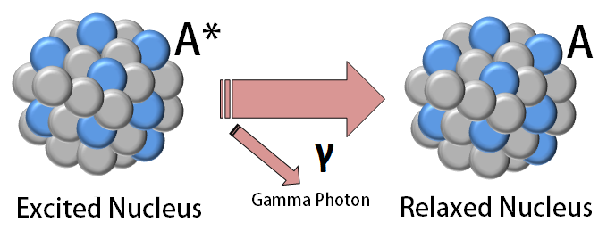

Continued on the next page

Group 6 – Radioactivity & Half-Life
- Definitions
  - Radioactivity: the emission of energy and/or particles from the nucleus of a large, unstable atom.
    - Stable: in terms of radioactivity, stable means a nucleus will stay together for a long time (in other words if an atom is stable it is not radioactive)
    - Unstable: in terms of radioactivity, unstable means a nucleus is likely to emit energy and/or particles. (in other words, if an atom is unstable it is radioactive)
  - Half-Life: the amount of time it takes for a radioactive sample to lose half of its original mass through radioactive decay. (note: there are different symbols used in the half-life equation however, they all perform the same calculation. For example the “A” and A₀” are sometimes written as “N_{t}” and “N₀”.
- Half-Life Equation:
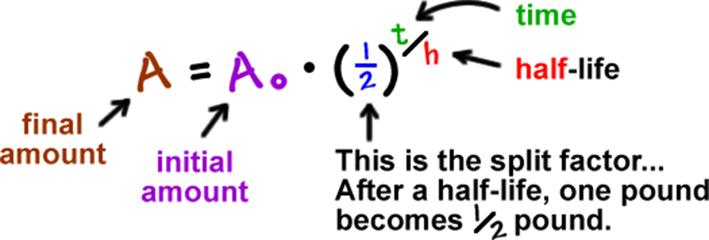
- Half-Life Example Graph:
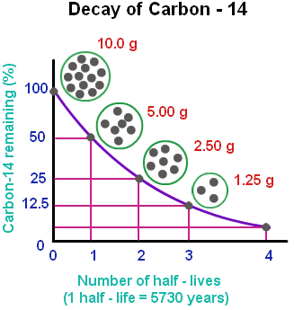
- Radiometric dating: a method of dating geological or archeological specimens by determining the relative proportions of particular radioactive isotopes present in a sample.

