Potential and Kinetic Energy WebQuest
- Go to the following website: http://www.learner.org/interactives/parkphysics/coaster.html
  - Read the opening page and answer the following questions on the opening page:
    - How does a roller coaster work?
    - What advantage do wooden coasters have over steel ones?
    - Why do you think wooden coasters act this way?
  - Click on “Design a Roller Coaster”
    - Read this page before progressing. Note the two main assumptions used for this coaster design at the bottom of the page:
      - Number of cars: _____________________
      - Mass of the cars: _____________________
Note: the web site says that the acceleration due to gravity is 32 ft/s/s; you will be using 9.8 m/sec² instead.
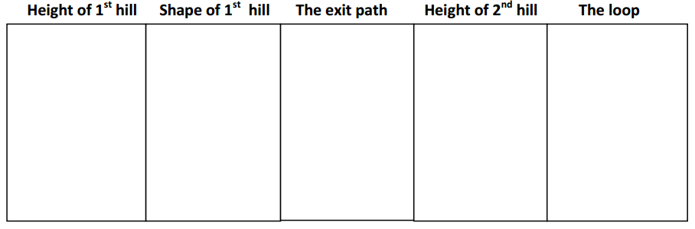
  - Click on Begin - Draw your initial coaster design. Be certain to note any measurements!
  - Calculate the potential energy of your coaster design at the each of the following locations using the equation GPE = mgh. Show your work for at least one example below.

PE: 1st hill:__________ 2nd hill:__________ Loop:__________
  - Assuming the fastest speed of the coaster is 27 m/s after the first hill, calculate the kinetic energy of your coaster design using KE = 0.5mv²
- What was the safety rating of your coaster? ___________________
- What was the fun rating? _____________________
Go to the following website: http://phet.colorado.edu/en/simulation/energy-skate-park
- Click on "Run Now"
- You will first see a skateboarder sliding back and forth.
- In the top right corner of the tool bar, select the box “Grid”
- In the middle of the tool bar on the right side, select the boxes for "Show Pie Chart" and "with Thermal". Click on “Energy vs. Position.” Move the graph out of the way.
- At the bottom of the page, you will see a selection titled “Sim Speed”. Slow the simulation down to about half-way.
- Looking at the Energy vs. Position graph, compare the kinetic energy to the potential energy.
  - What is the maximum amount of kinetic energy (in joules) the skater reaches?

  - What is the maximum amount of potential energy (in joules) the skater reaches?
  - Compare these numbers and what you see on the graph. What happens to the potential energy as kinetic energy decreases? Why does this happen?

- At the top of the tool bar on the right side, select the button labeled “Choose Skater”. Pick a different skater.
  - Which skater did you choose:_____________
  - What is the mass of this skater?_____________
  - What is the maximum amount of kinetic energy (in joules) the skater reaches?
  - What is the maximum amount of potential energy (in joules) the skater reaches?
  - How do these amounts compare to the first skater? What explains the differences?

- At the top of the tool bar on the right side, select the button labeled “Choose Skater”. Pick a third skater.
  - Which skater did you choose:_____________
  - What is the mass of this skater?_____________
  - What is the maximum amount of kinetic energy (in joules) the skater reaches?
  - What is the maximum amount of potential energy (in joules) the skater reaches?
  - How do these amounts compare to the first two skaters? What explains the differences?

- At the middle of the tool bar on the right side, change the skater’s location (for example he can be on the moon, Jupiter, or space).
  - What do you notice happening to the kinetic and potential energy at each new stop?
    - Earth

    - Moon

    - Space

    - Jupiter

- Go back to Earth. At the bottom of the toolbar, hit the button that says "Track Friction>>" and change the coefficient of friction.
  - What happens to the skater now that there is friction?

  - What is happening to the kinetic and potential energy? What type of energy is it converting into?

  - What happens to the skater once the thermal energy reaches its maximum?

  - Does this happen sooner with a higher or lower amount of friction?

- Feel free to experiment with the track and additional settings. You can add track piece using the button in the upper left-hand corner. You can change the original track by clicking and dragging.

